# Functional test

For ensuring that it’s met all the requirements functional tests are used in software development. It is a way of confirming the program that assures all the required skills specified on the desktop are gathered. The following functional testing is listed below:

|  |  |  |  |  |  |
| --- | --- | --- | --- | --- | --- |
| **Id** | **Title** | **Pre-Condition** | **Test Step** | **Actual Result** | **Excepted Result** |
| **3.1** | Add news | Admin must be logged in the site | Adding news title, image and text | Admin can add news | Except |
| **3.2** | Contact us form | User must be visiting the site | Adding news title, image and text | User can submit the form | Except |
| **3.3** | Weather forecast | User must be visiting the weather page | Visit the site | Show correctly weather information | Except |

**3.1 Add news**

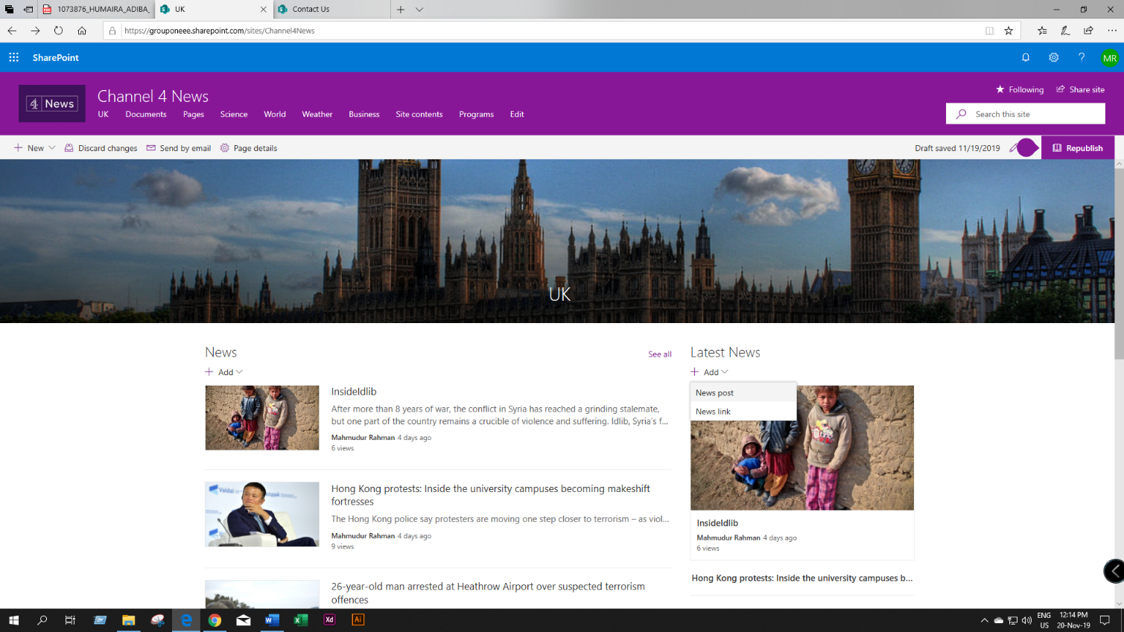

Figure 4: Click on add and then click on news post

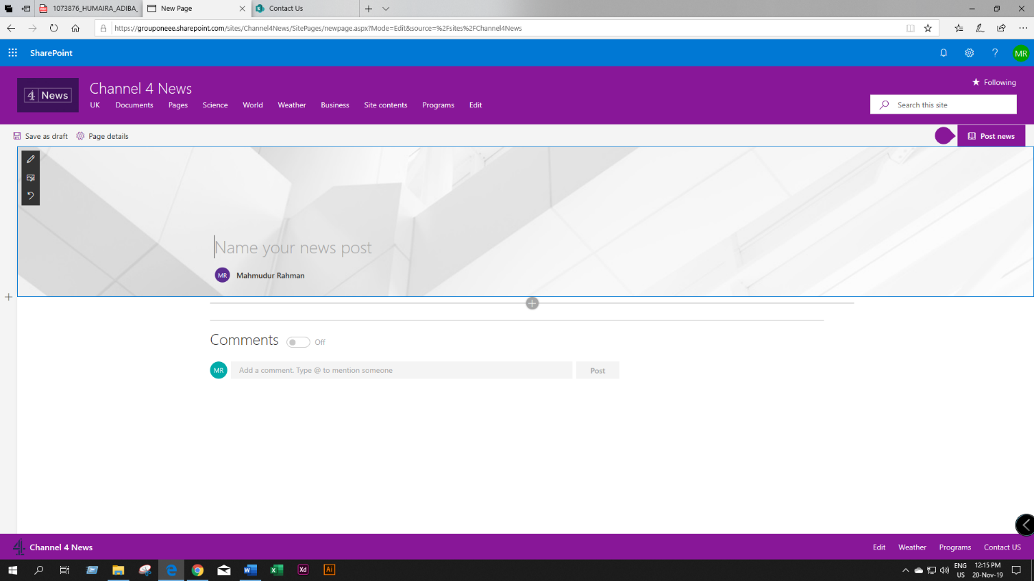

Figure 5: Adding a news title

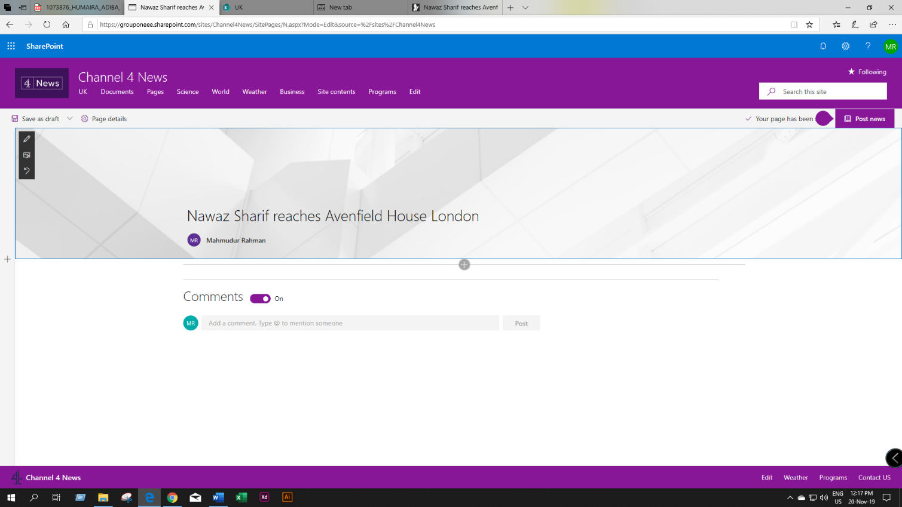

Figure 6: News title added successfully

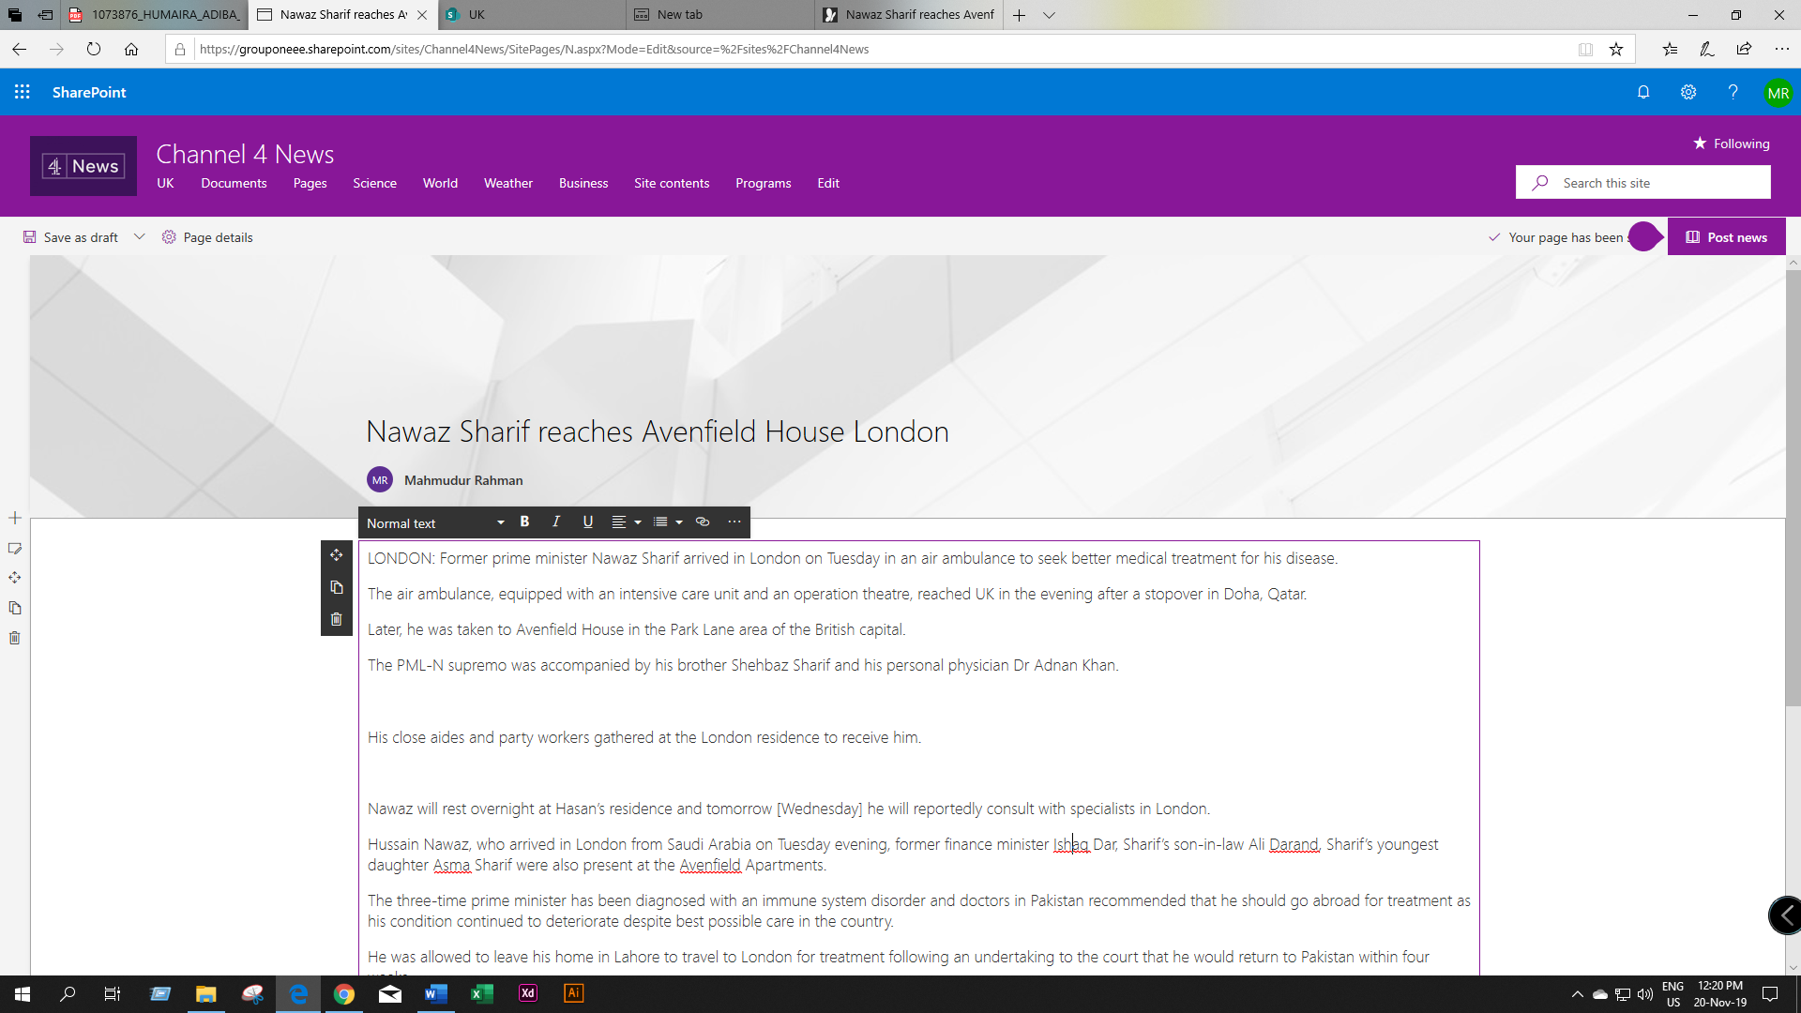

Figure 7: Adding news content

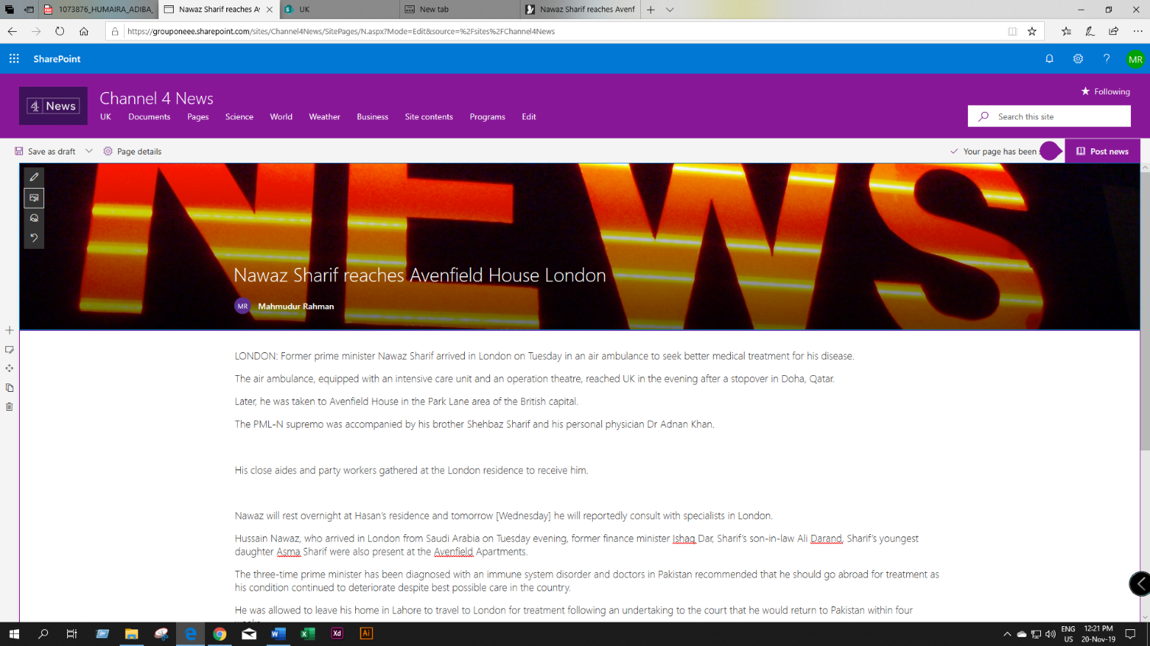

Figure 8: Adding news image

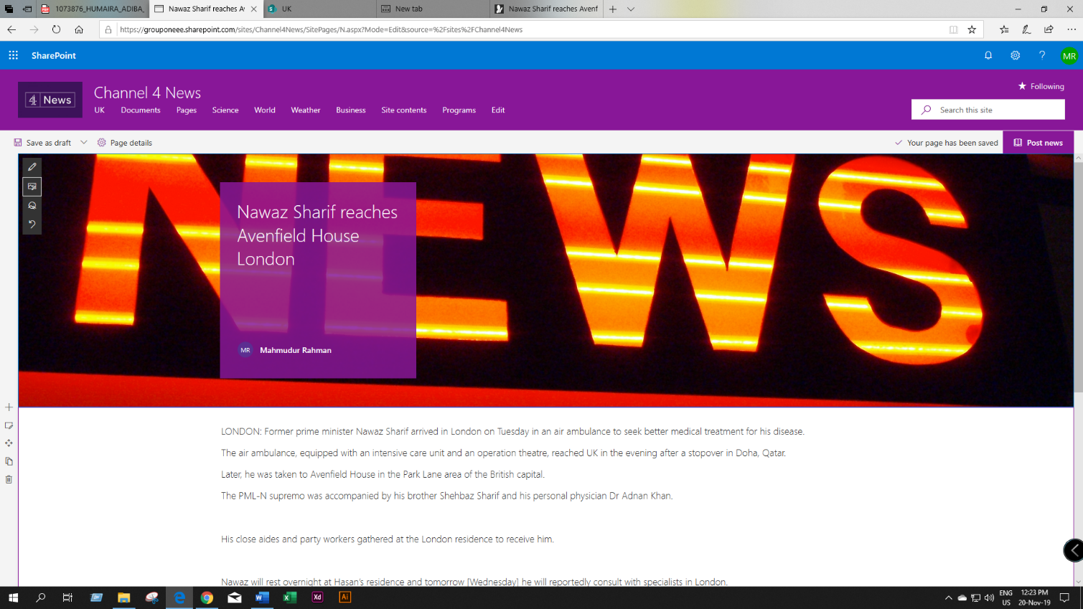

Figure 9: Post added successfully

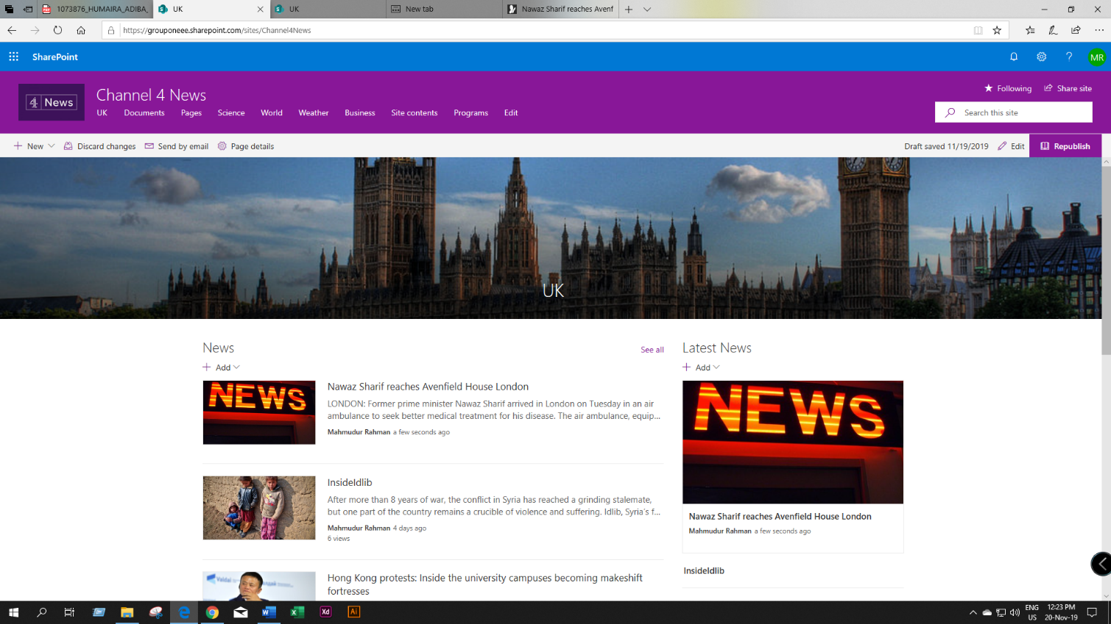

Figure 10: New news show on home page

**3.2 Submit contact us form**

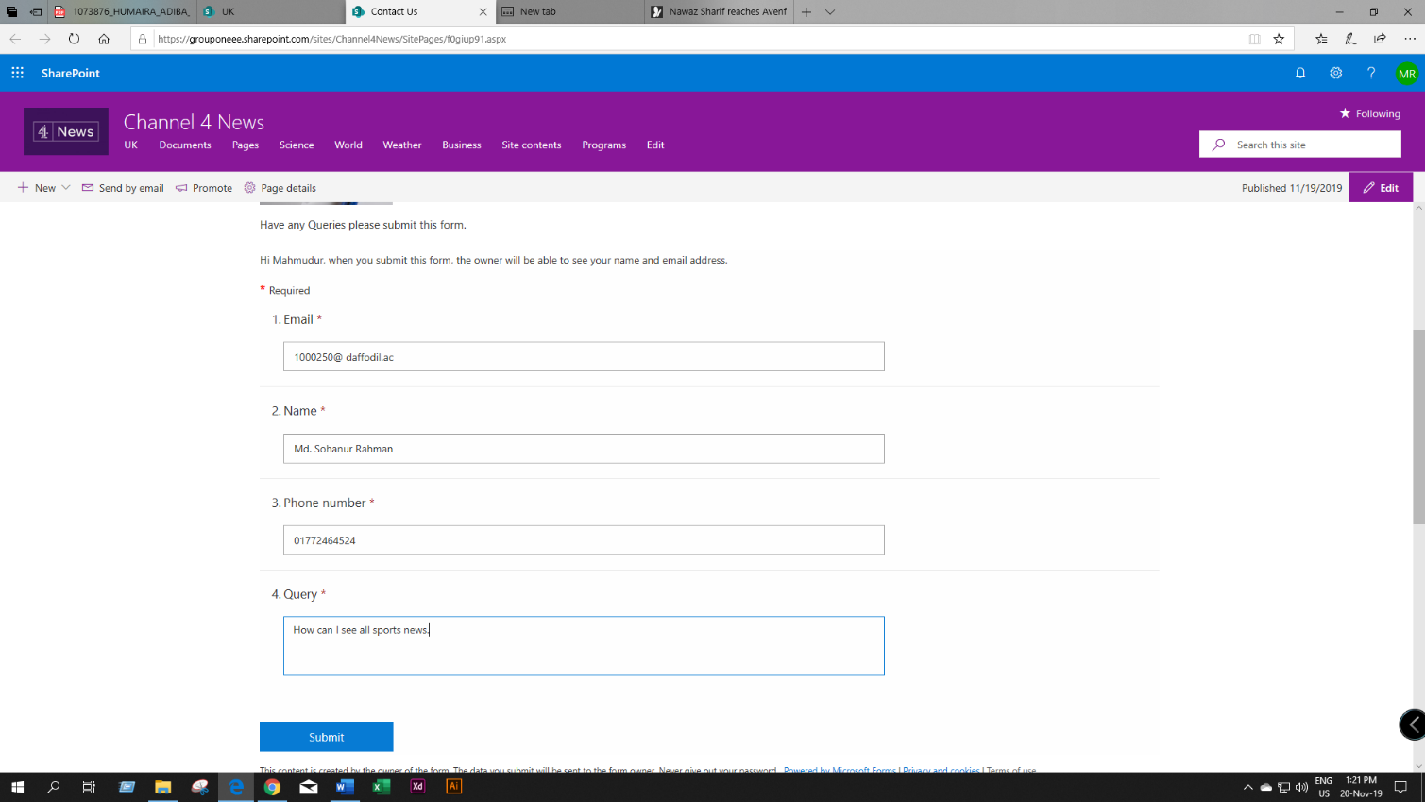

Figure 11: User fill-up contact us form

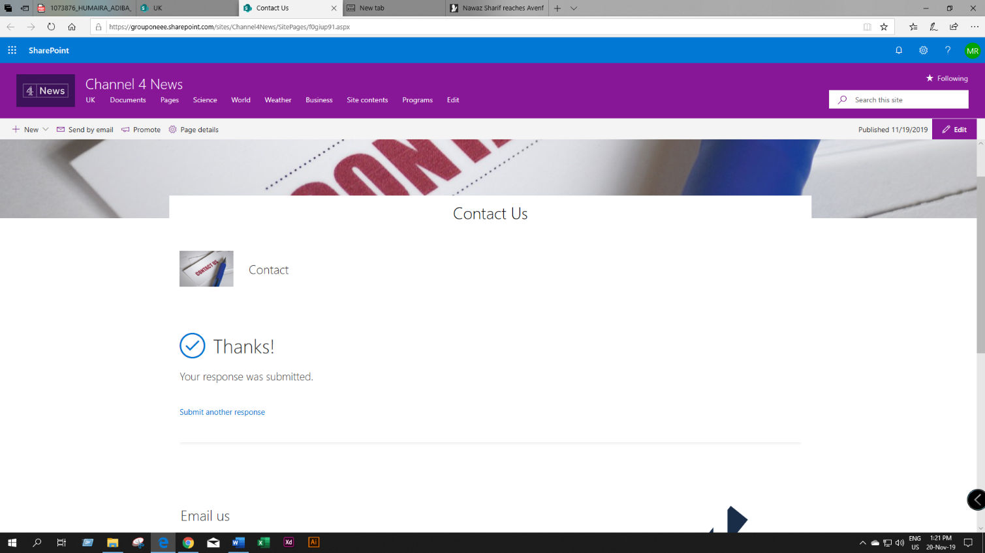

Figure 12: Form submission successfully

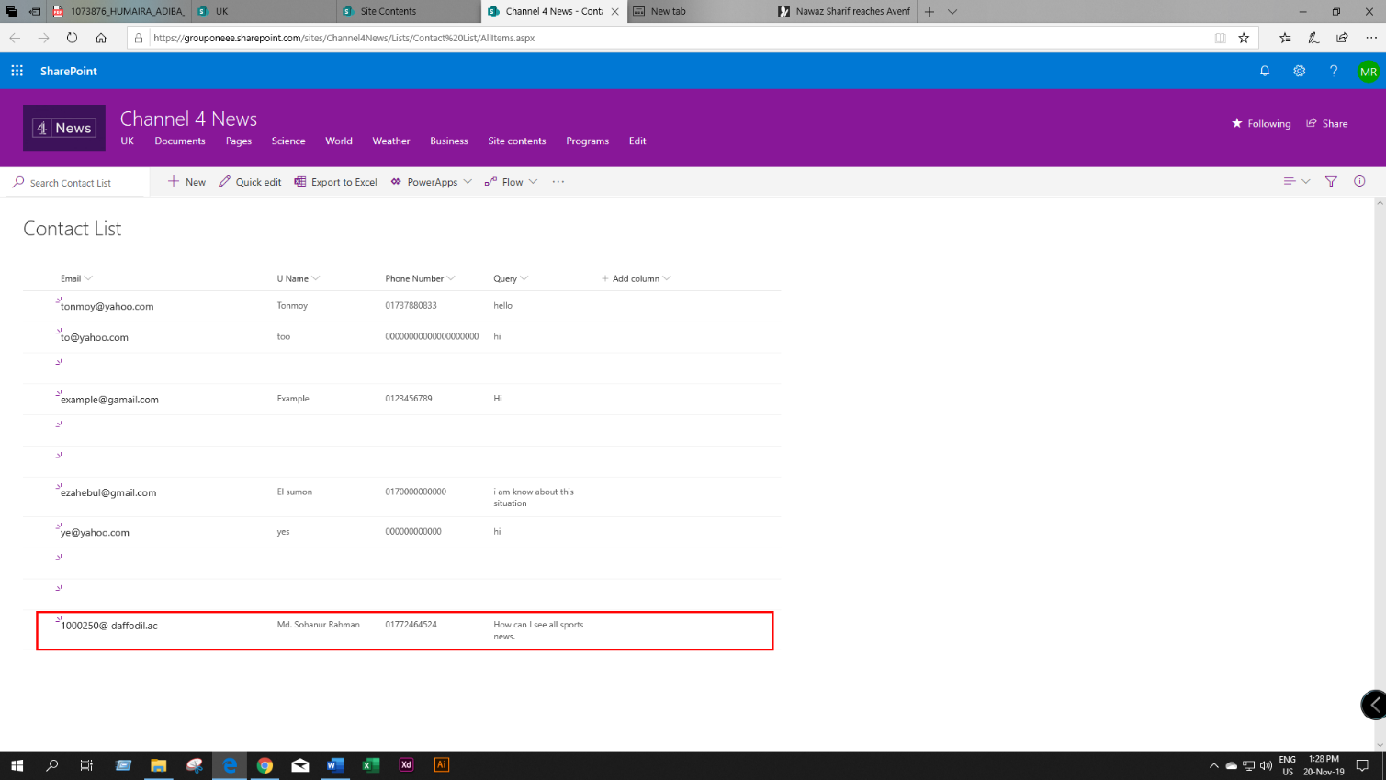

Figure 13: User submit data

**3.3 Weather forecast**

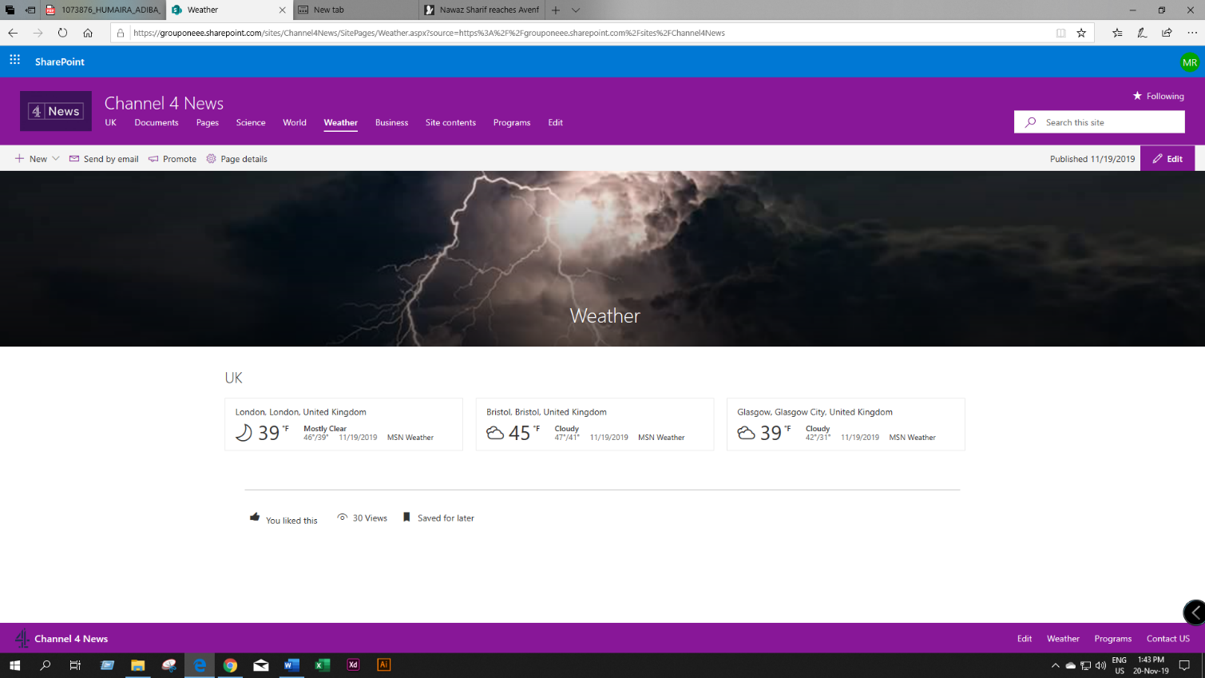

Figure 14: Show weather forecast